Manly ferry campaign: How you can help save the vessels
The Save Manly Ferries campaigners are launching two last events before the matter is debated in parliament. Here’s what you can do.
Julie Cross
@juliejourno
5 min read
March 12, 2021 - 5:00PM
Manly Daily
The Save Manly Ferries group is stepping up its campaign in the run up to a debate in NSW parliament due at the end of the month.
More than 22,000 people have signed a petition forcing the issue to be tabled in state parliament on March 25.
It follows last year’s announcement from the NSW Government that it plans to replace the iconic Freshwater class ferry from the Manly to city route during the week, with three smaller and faster Emerald class ferries.
Two of the four large ferries have been saved following uproar in the community and will operate on the weekends and public holidays.
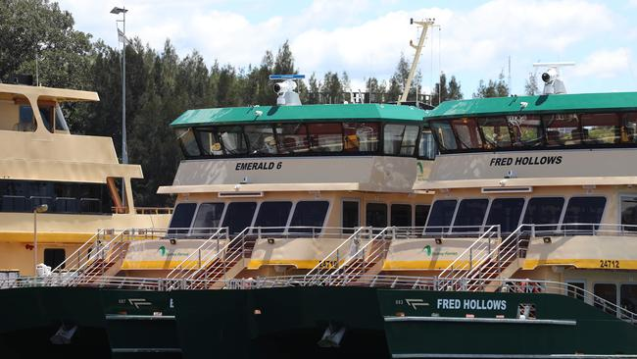
Sydney's new ferry, the Emerald 6, formerly named Ferry Mcferry Face, docked in Balmain, Sydney, Australia, 03 December 2017.
But the Save Manly Ferries group spearheaded by Deputy Mayor Candy Bingham wants to retain all four of the large vessels and says it will be easy to convert them to electric.
This weekend supporters of the ferry will be encouraging the 1,000 people who want to keep all four ferries to have their photos taken and used in a photo montage that will spell out a message.
“It is really very clever technology,” Cr Bingham said.
“It’s another way to raise awareness of what is happening.”
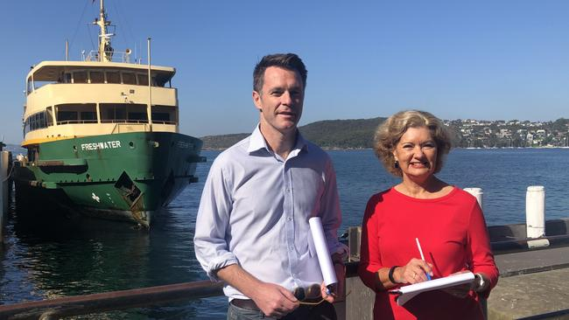
Shadow Transport Minister Chris Minns and Cr Candy Bingham, in front of one of Manly's iconic Freshwater class ferries, which will soon disappear under a shake-up of ferry services. Picture: Julie Cross
She said the 1.5m by 2m board will be the first time this technology is used in Australia.
Cr Bingham is encouraging anyone to take part in this “moment in time in Manly’s history” between 10am and 3pm on Sunday, near the ferry terminal inside the wharf.
Then on March 20, Cr Bingham is encouraging people to wear blue and white and meet at Manly Cove to hear an expert talk about converting the ferries to electric and a wheelchair user about his concerns using the Emerald class ferries.
Then she wants supporters to “catch the ferry to save the ferry”.
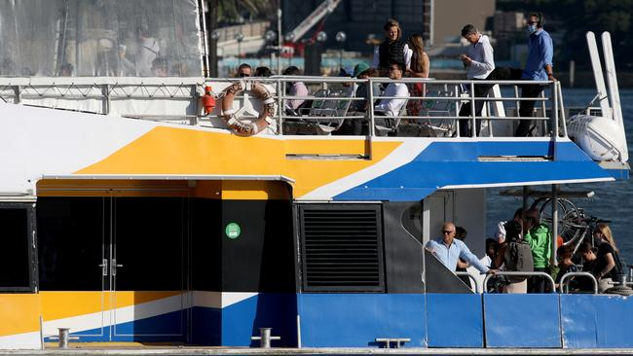
SYDNEY, AUSTRALIA - NewsWire Photos MARCH 4, 2021: Morning commuters some pictured in masks some withouts masks heading towards Circular Quay on the Manly fast ferry. Picture: NCA NewsWire / Damian Shaw
This week a spokesman for the NRMA that runs the Manly Fast Ferry also revealed its stance on the new Emerald class ferries and what it will mean for its business.
The spokesman said the NRMA was committed to serving the community post the introduction of the more competitive Emerald class service on the route and will look to re-sign the contract in 2022.
The new faster public ferries will take around 22 minutes to complete the Manly to city journey, compared with the fast ferry which is between 18 to 20 minutes.
The spokesman said the fast ferry was the first choice for commuters and the majority of users.
He said it has consistently been the number one choice compared with the public ferries in a bi-annual TfNSW Customer Satisfaction survey.
At the moment the fast ferry also carries more than 50 per cent of the passengers overall.
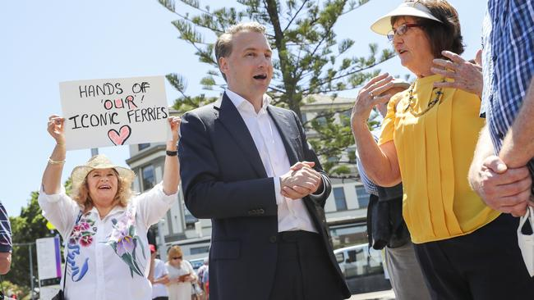
Protest to save Manly Ferry organised by James Griffin, Manly MP, to get people onboard the Manly Ferry. Supporter Patsy Clayton-Fry holding her sign. Picture: Dylan Robinson
Manly MP James Griffin said there will be those who are money conscious who will choose a slightly longer journey, so they can take advantage of their Opal card on the new Emerald class ferries. But he said there was plenty of room for the two services.
He supports the new Emerald class ferries and helped fight to save two of the larger vessels for weekends and public holidays.
“The forecast for people returning to public transport is strong,” he said.
“I certainly support reduced trip times with the Emerald class which will provide commuters with choice.
“Having some competitive tension between the fast ferry and Sydney Harbour ferries will encourage both to provide better services for the commuter.”
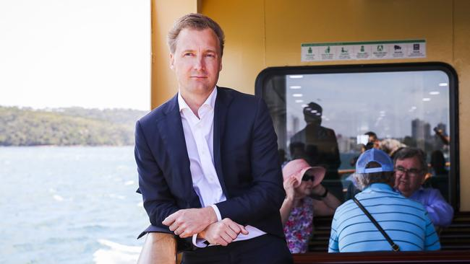
Protest to save Manly Ferry organised by James Griffin, Manly MP, to get people onboard the Manly Ferry. Picture: Dylan Robinson
Mr Griffin said he will be speaking during the debate on the Manly ferries, but any discussion will not stop plans to introduce the Emerald class ferries.
He was unable to say when the new vessels will be introduced.
You can watch the debate on the Manly Freshwater class ferries live online on Thursday, March 25, at 4pm:
https://www.parliament.nsw.gov.au/pages/la-webcast-page.aspx

